WEAVER VALE PRACTICE

Patient Survey

The practice, along with the Patient Participation Group (PPG), undertook a survey during March to obtain the views of our patients around a number of areas. The aim of the survey was to understand where the practice may be able to make improvements.

The PPG gave out the questionnaires to the patients in the waiting room and 114 responses were obtained, not all questions were answered.

The form also asked patients to provide contact details if they were interested in joining the PPG, a total of 17 patients have expressed an interest and will be contacted.

Appointments

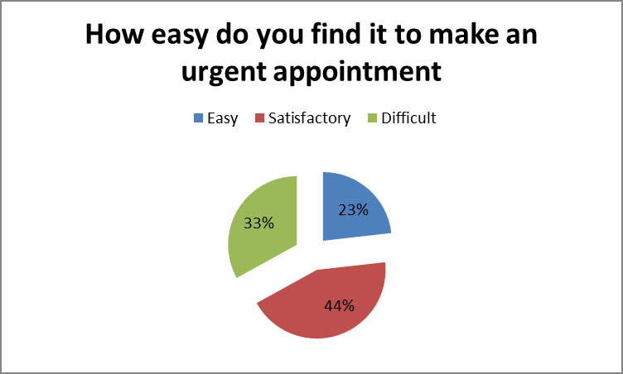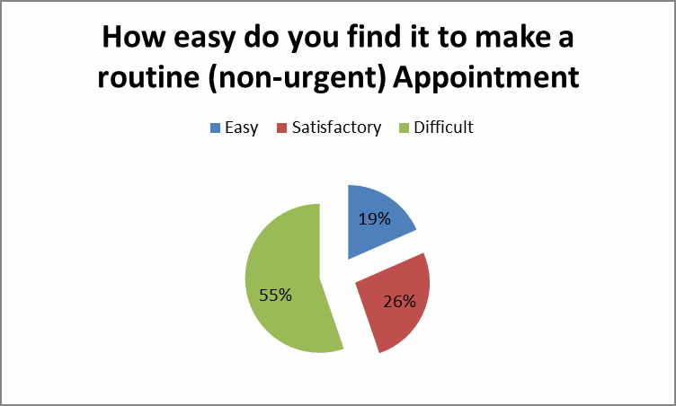

Comments:
I’ve never needed to obtain an urgent appointment

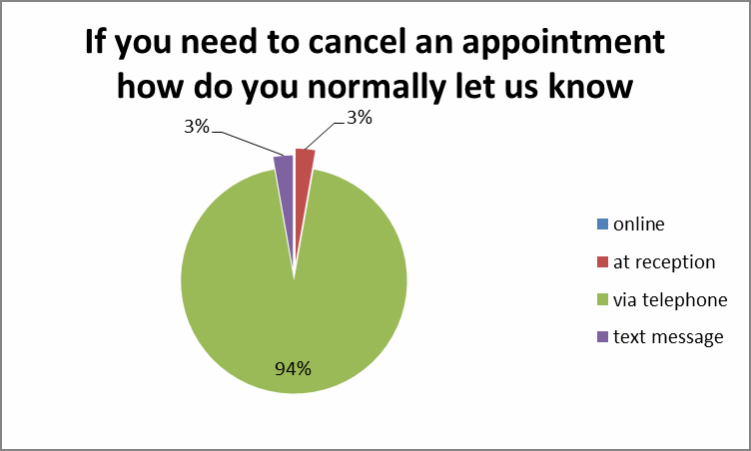Appointments

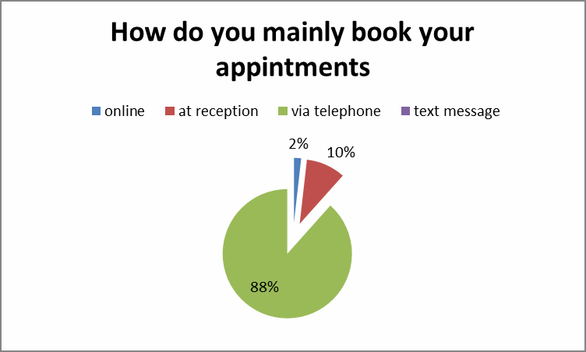

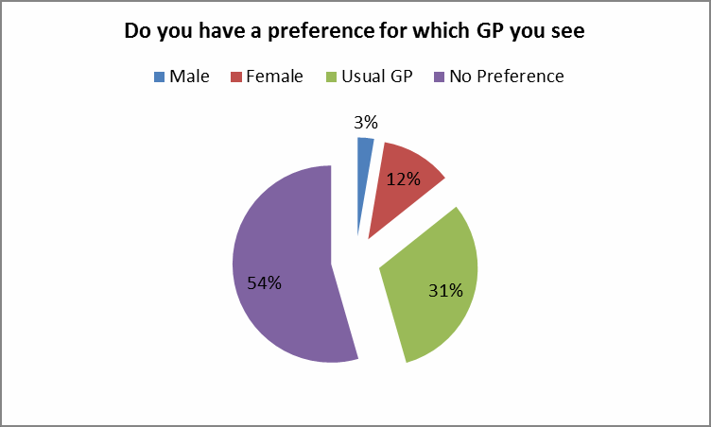
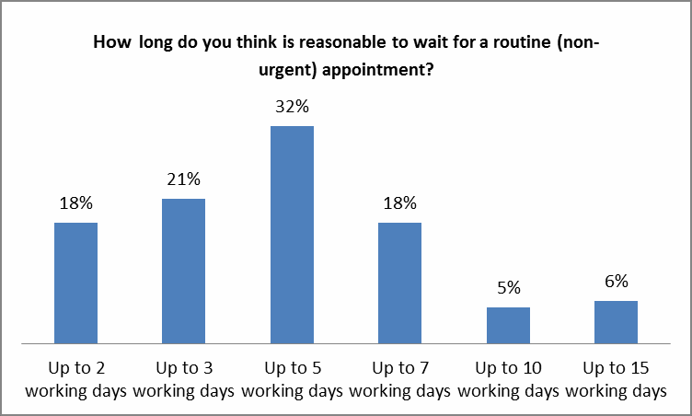Page 2 of 2

GP Preference

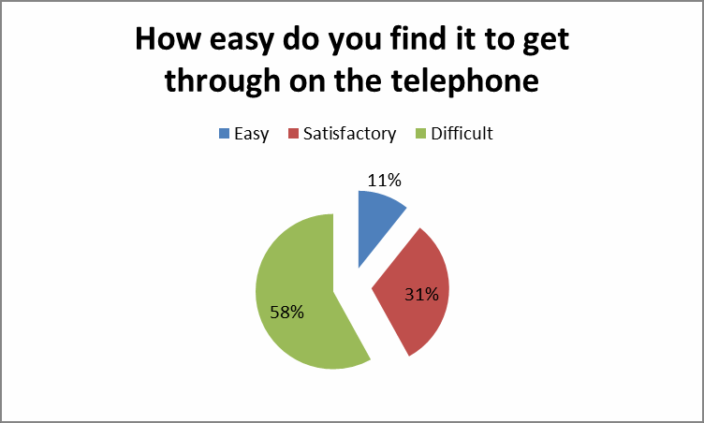Telephone Access

Page 3 of 3

Treatment of Reception and Nurses

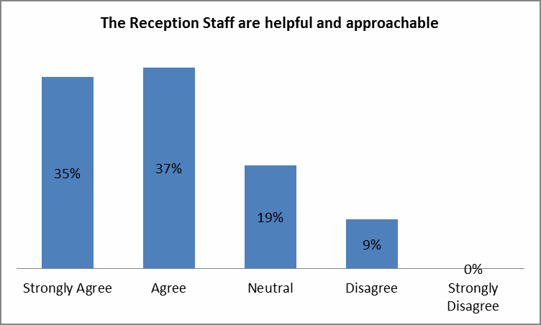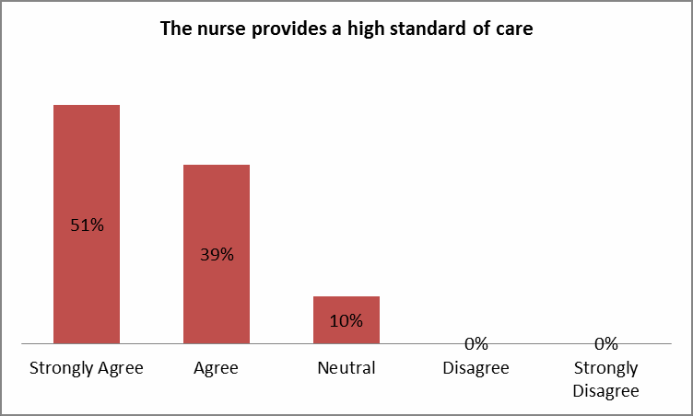

Treatment of Doctors

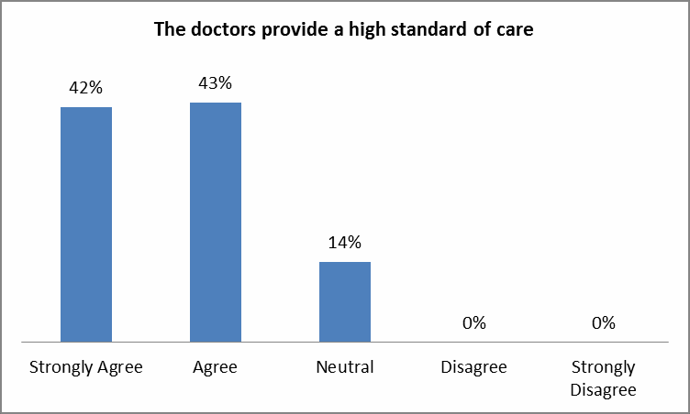

Comments
- Depends on the doctor. Dr Beynon strongly agree
- Depends on the doctor. Dr Beynon high standard, good treatment
Page 4 of 4

yes No
12%
15%
40%
88%
85%
60%
Do you think the practice should have a dedicated DO you think the practice should have a dedicated Do you think the practice should provide test results
phone line for prescriptions phone line for test results by text message

Comments
- It would depend on the result as to whether I would want to receive it by text.

Page 5 of 5

Text Messaging

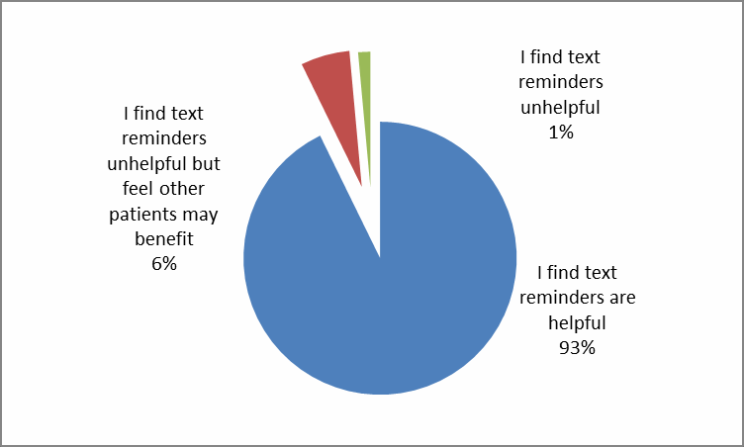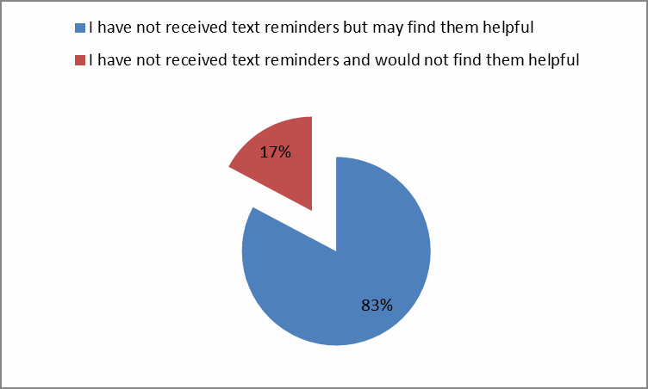

Page 6 of 6

WEAVER VALE PRACTICE

General Comments
- When you call at 8.30am can’t get through, never any appointments. When I have had a call back problem not always help to be sorting, then end up in out of hours doctors that event then in hospital, can feel rushed by certain doctors"
- Waiting time in doctors is too long. Hard to get through on phone no one answers for ages. Some doctors make you feel rushed plus not always helpful with your problem, only doctor in this practice which is Dr Beynon seems to know what is wrong with you and able to sort your problem. He is the best
- No hold time or position in a queue when you first call up. You should be able to text or ring and do a repeat prescription over the phone. It needs to get into the 21st century show your name in lights instead of shouting your name
- I'm a very poorly patient because I have lupus, asthma and other problems but sometimes it is very difficult to see my doctor the day I need, other times I need waiting 3 weeks for an appointment, sometimes I need more time for appointment. The rest I'm very pleased. Thanks
- Waiting time to see a doctor should not have to wait 3-4 weeks
- You never get to see the same doctor twice
- I am tired of being "fobbed off". They do not care about certain problems (mainly young doctors). Thank god for Dr Fearon and Dr Beynon I also hate waiting for so long to be told the same thing over and over again
- I came to see Dr Jess and received excellent care for my 9 year old daughter. She was fantastic, really thorough and helpful and I came away feeling I had received excellent care.
- Do not understand why told to call at 8.30am when no one answers the phone til at least 9.15-9.30am then to be told no appointments!!
- something desperately needs to be done about the waiting times for an appointment with the GPs. Can sometimes be waiting up to six weeks
- Frustrating knowing that cars are parked for people going to the hospital so that patients cant park
- It is a fantastic practice. My only concern is the difficulty getting through on the phone. Luckily I have transport so I just call in if I need to book appointment for a family member
- I think sometimes you have to wait a lot longer for an appointment, urgent or non urgency even if you already have an appointment booked. Everything else is very helpful and the staff are very understanding. So thank you
- I think more doctors are needed in this surgery
- Problem parking in car park due to hospital patients using it to park so they don’t have to pay charges.
- My wife and I like to see Dr Beynon if possible each time we visit. No problems with the staff at all, very helpful
- would be good if you could have the same doctor, not always possible
- the appointment I have today was made 4 weeks ago, with my named GP. Unacceptable
- Vey clean, well presented practice. The doctors are amazing. The only think I feel lets the practice down is the phone lines. Although I feel this is NHS wide and something that needs discussion NHS wide
- Boots pharmacy needs to coordinate better with regards to prescription amounts with doctors
- I think they should release appointments on the day when you ring at 8.30am they need to answer the phone as soon as they hear it and not leave it for ages
- Can be hard to get appointment to see the doctor of your choice as can be booked four weeks in advance
- very good very helpful I have no problems
- Youngest receptionist I do not find helpful much, a lot of the ladies that’s been here for years are a lot more dedicated to help. The rooms need to be more adapted for disabled as if my son has to come in to be examined I cannot lie him on the bed as its not wide enough and most rooms are too small to lift him out and get a wheelchair in
- Lots of over 60 don’t have mobile phones, just have land line so texts would be useless
- Wait too long to get an appointment, husband tends to not come now a it is sometimes 3-4 weeks before he can get an appointment with his doctor

- Never had any problem with the practice usually seen with enough time and doctors have always been helpful
- I did not know that there were any online booking facilities. I think receiving test results and prescription ordering would be better online so as to reduce burden on phone calls. Overall I have to say I do think this is one of the better practices in the area and am generally happy
- Cannot get an appointment to suit working hours. Diary often does not go far enough at reception when you wish to make a follow up appointment. It would be easier to reorder prescriptions online
- Lately there seems to be problems getting through to doctors phone line, rings for ages not enough staff are in reception and long wait for routine appointments
- I find this practice is very helpful and have no problems with anything and any way all the receptionist are always helpful and polite and the doctors and nurses are very understanding
- Always been treated with the utmost respect.
- Waiting a month for a routine appointment is unacceptable
- I find when I come to the doctors you are not seeing the same doctor, seeing your own doctor all the time you get to know them and same with the doctors, you don’t have to go back with history and you can talk to
- I find it frustrating when I put a repeat prescription on line and it is accepted within 2 days and my husband has put a repeat prescription on line on the same day and there days late it is not been accepted yet
- Stop hospital patients using the car park because most days theres no space to park.

Page 8 of 8

